Table of Contents

Introduction of Variables 2

PHP Variables 3

Python Variables 3

# Introduction of Variables

In this definition found on TechTarget a Variable is described by, “a value that can change, depending on conditions or on information passed to the program. Typically, a program consists of instruction s that tell the computer what to do and data that the program uses when it is running.” (TechTarget Contributor, 2021)

## How to create a variable

To create a variable all you need to do is supply the variable with a name for example, if I wanted to create a system where I could save the reference for each book, I used for some University work I could create a variable that’s job is to store important information. Names of authors, page numbers, book titles, etc all searched for as soon as I download a book. Then I will program it to sort the words into the order of the Harvard referencing standards (different referencing standards will be available too). This will appear as a pop up on the side of web browser and with this I could click any reference and have it copied to put in my essay’s.

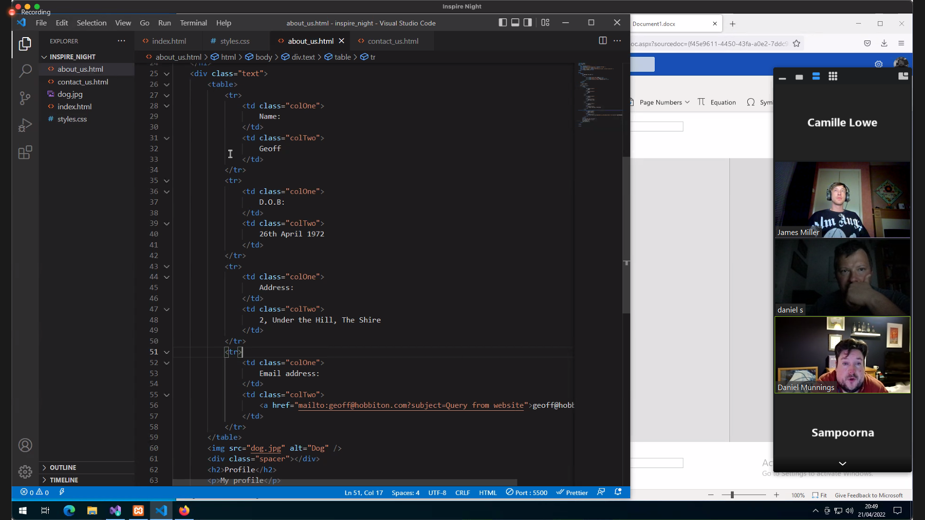

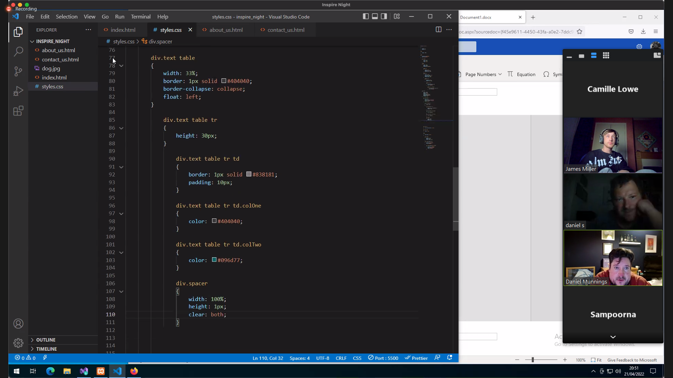

## PHP Variables

## Python Variables

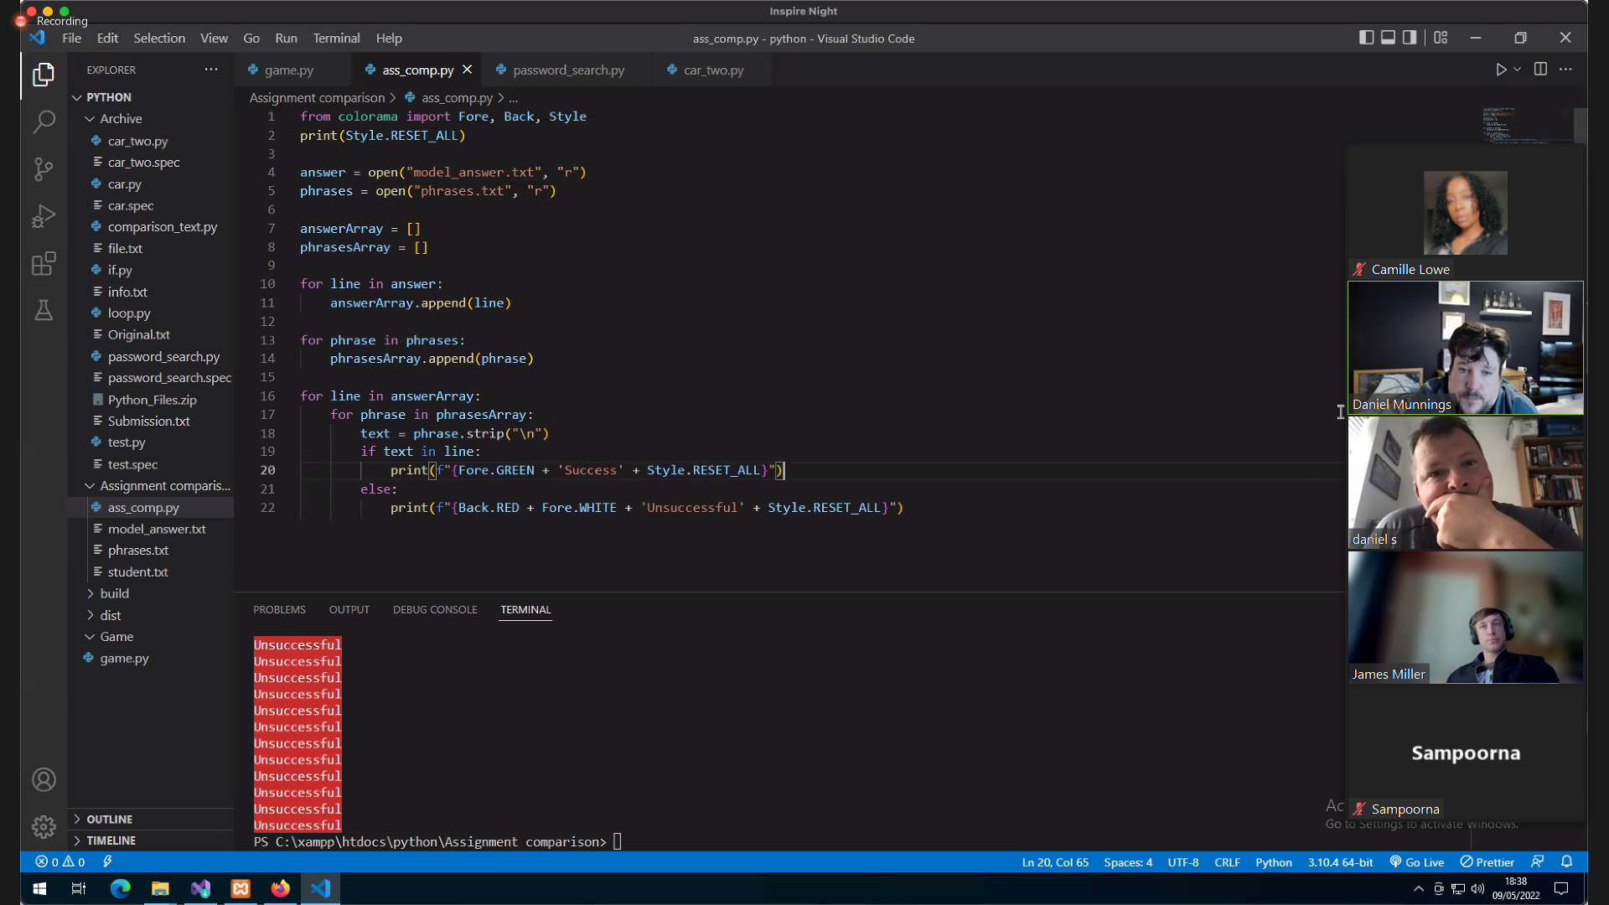

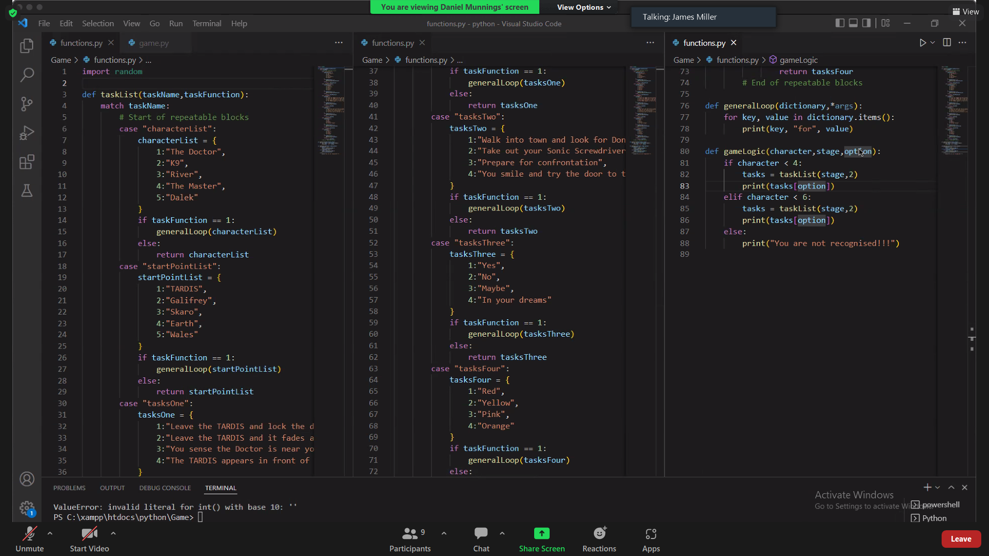

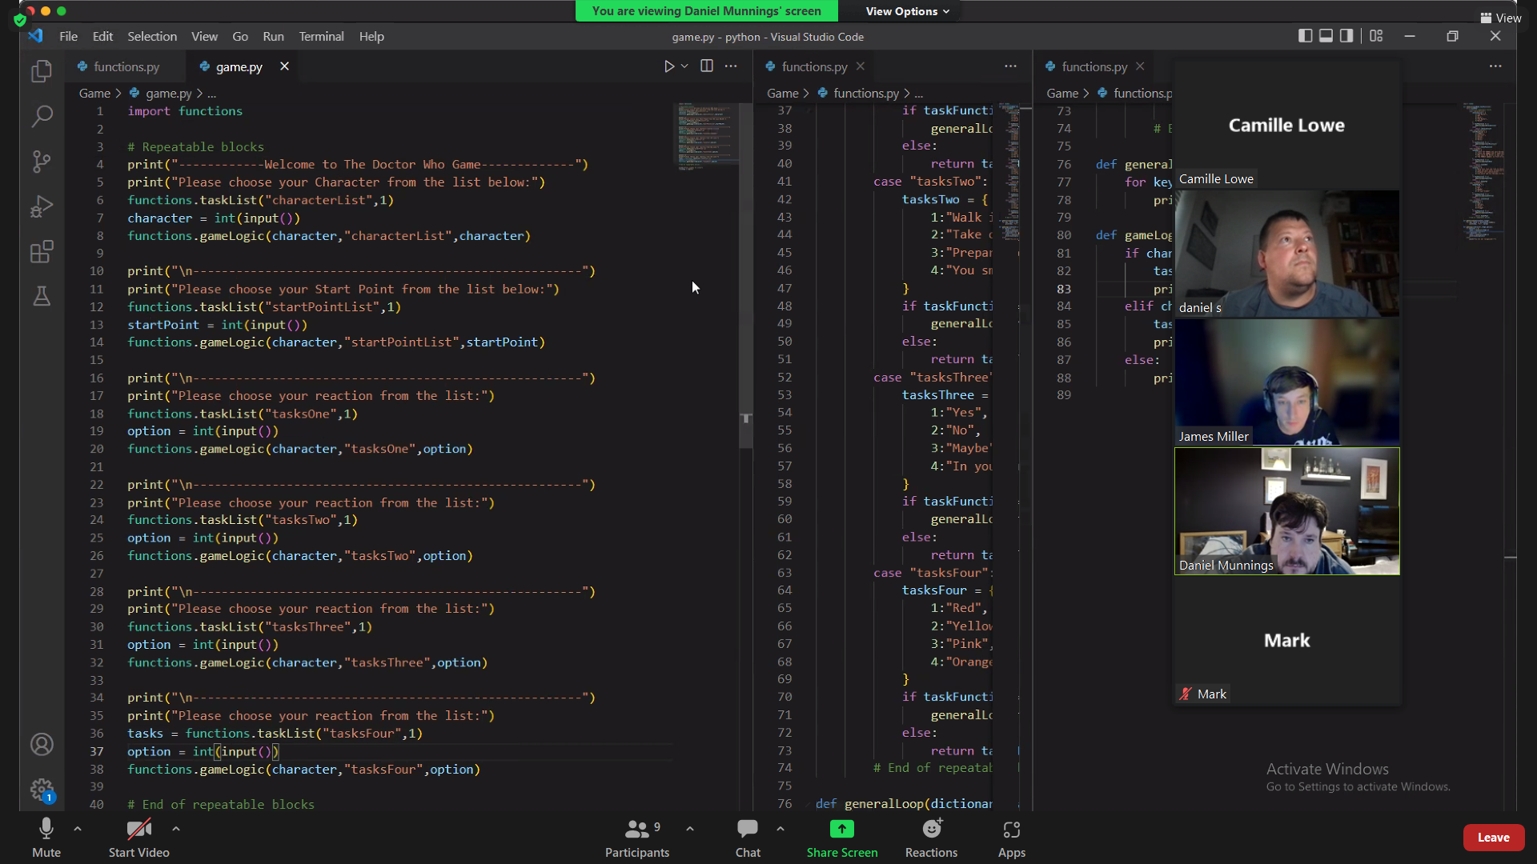

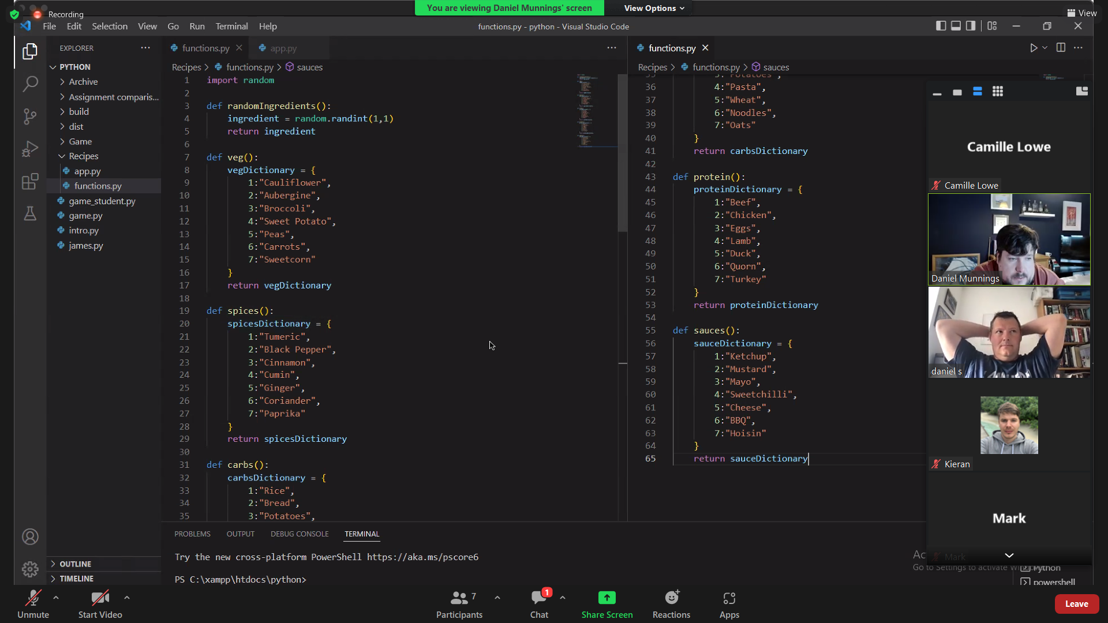

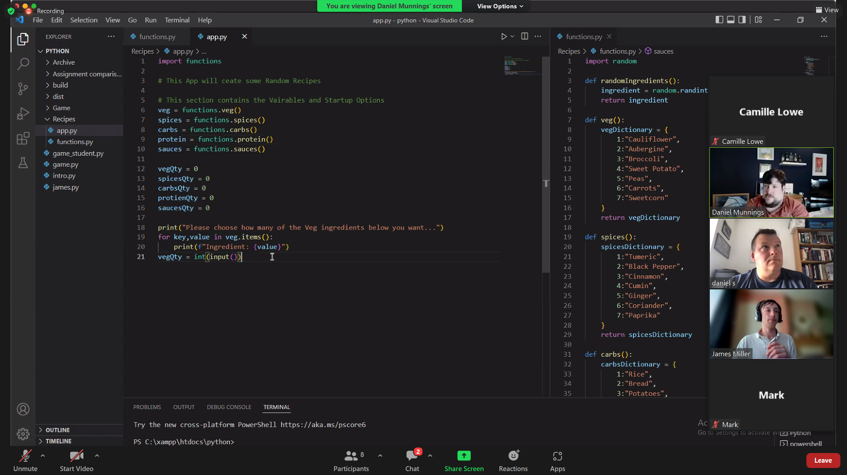

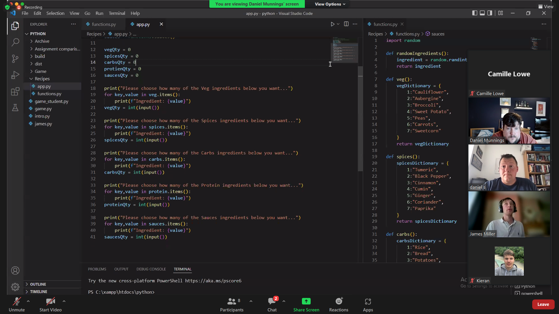

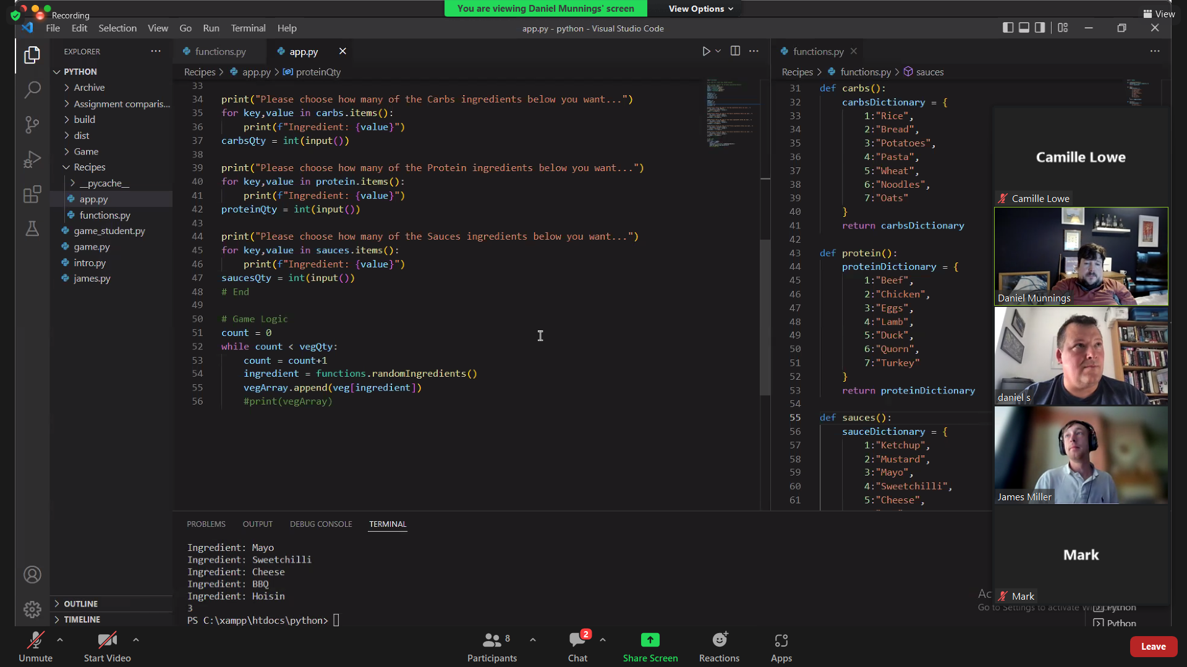

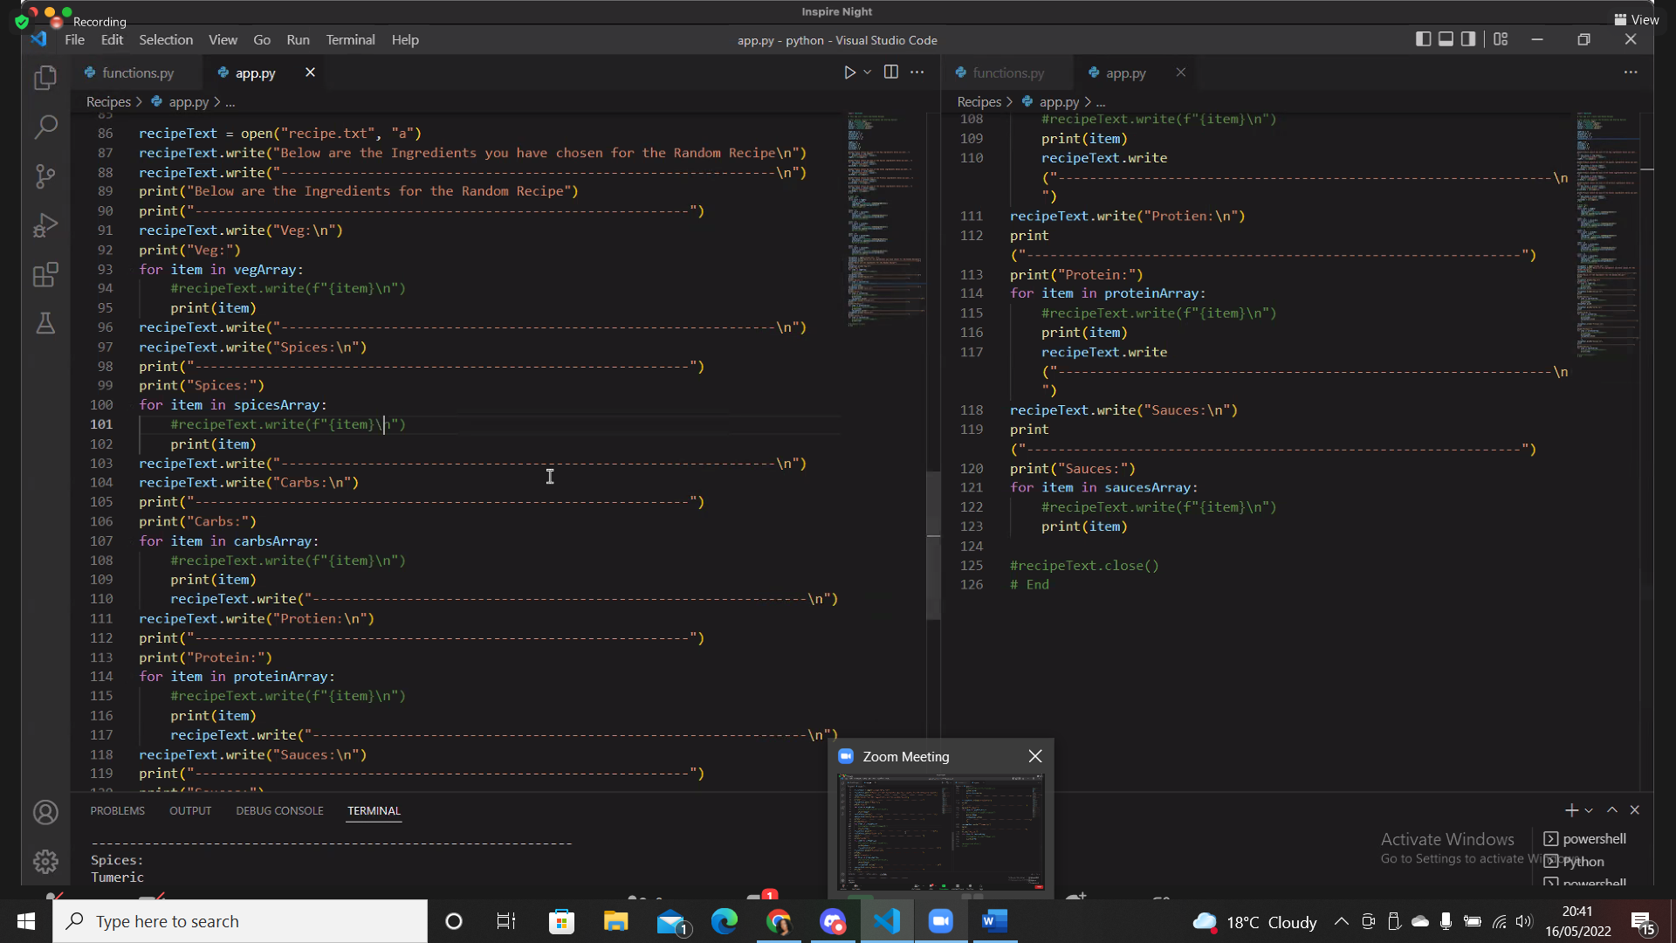

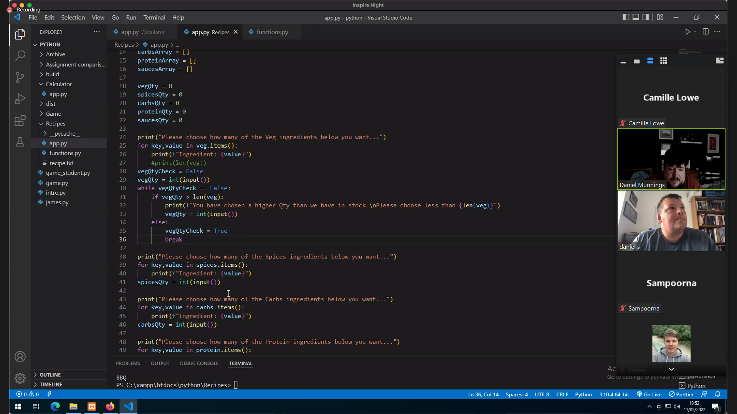

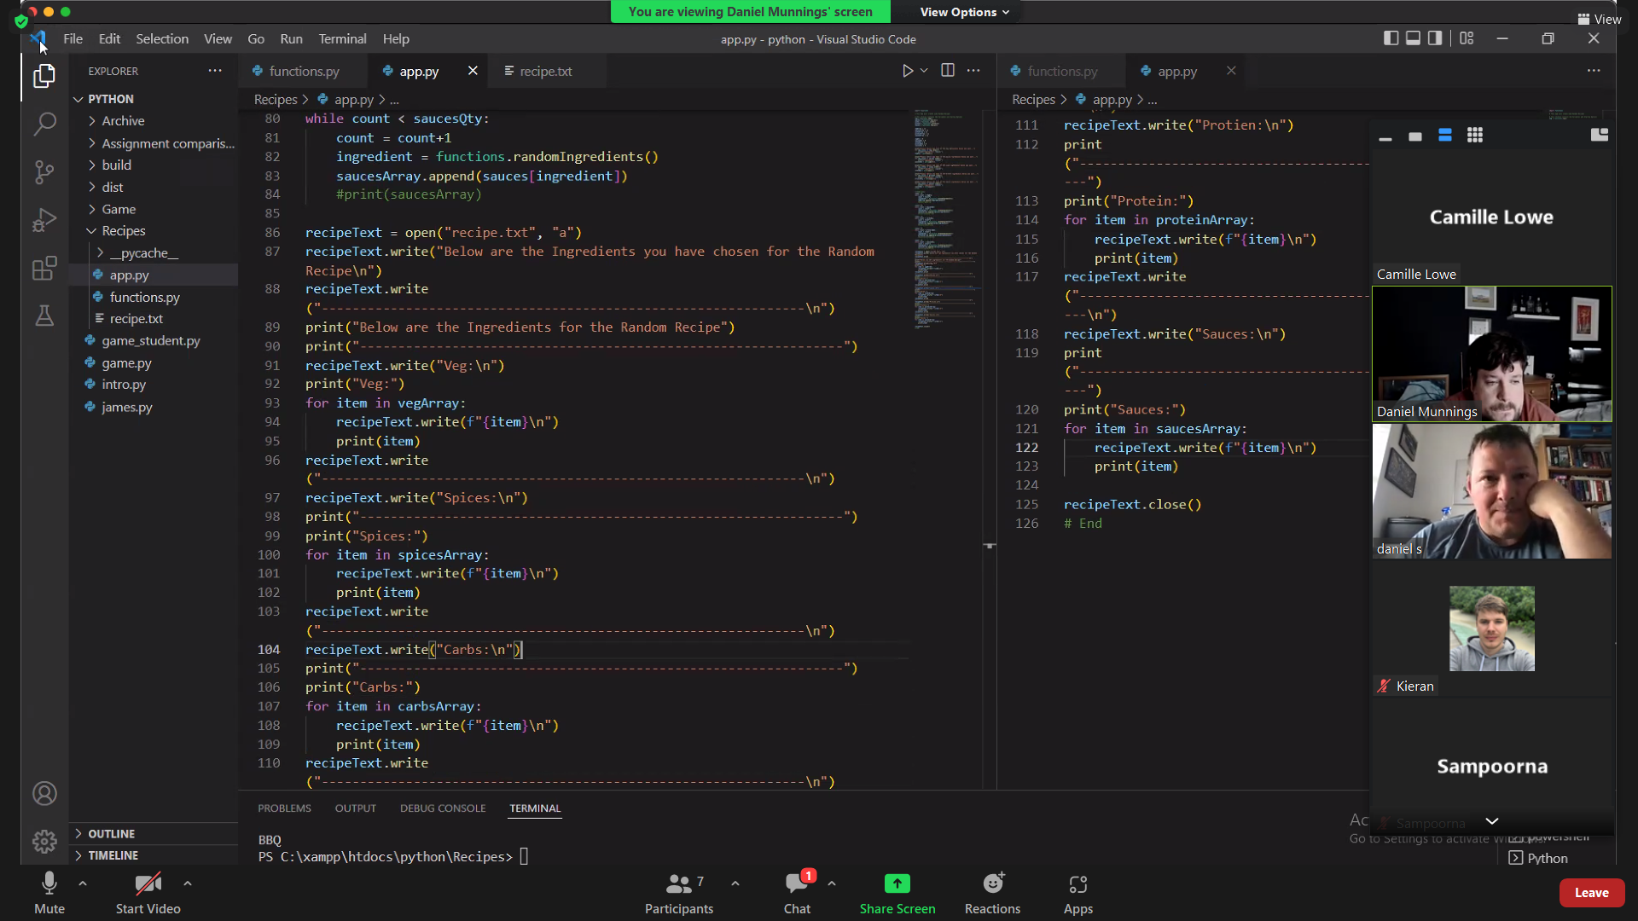

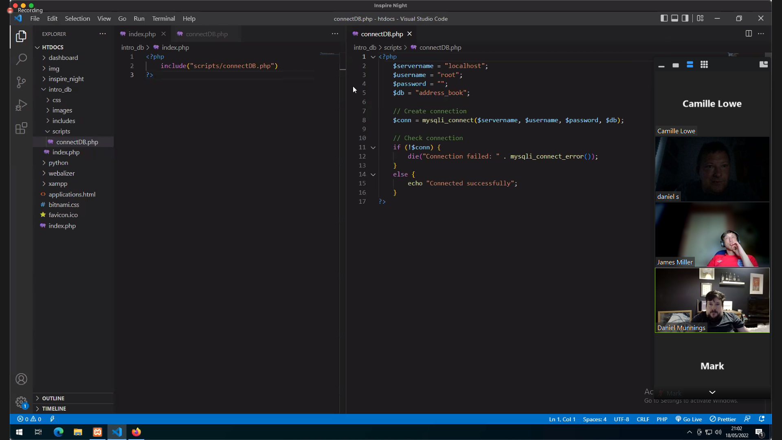

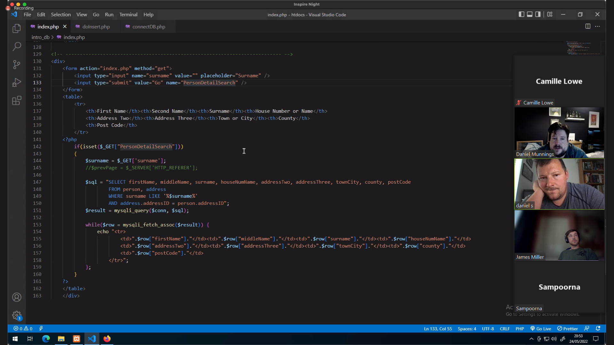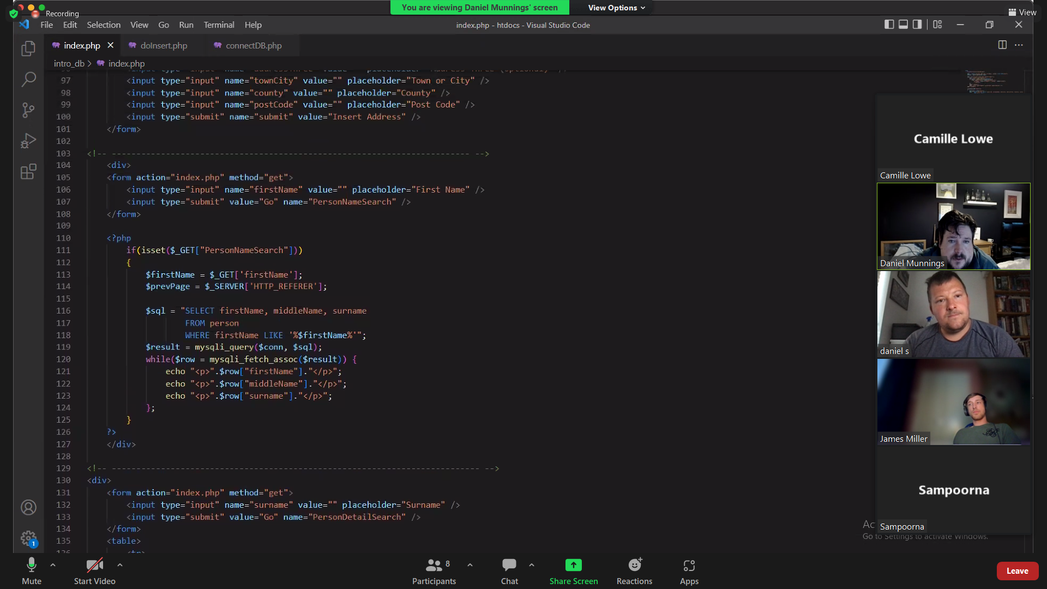

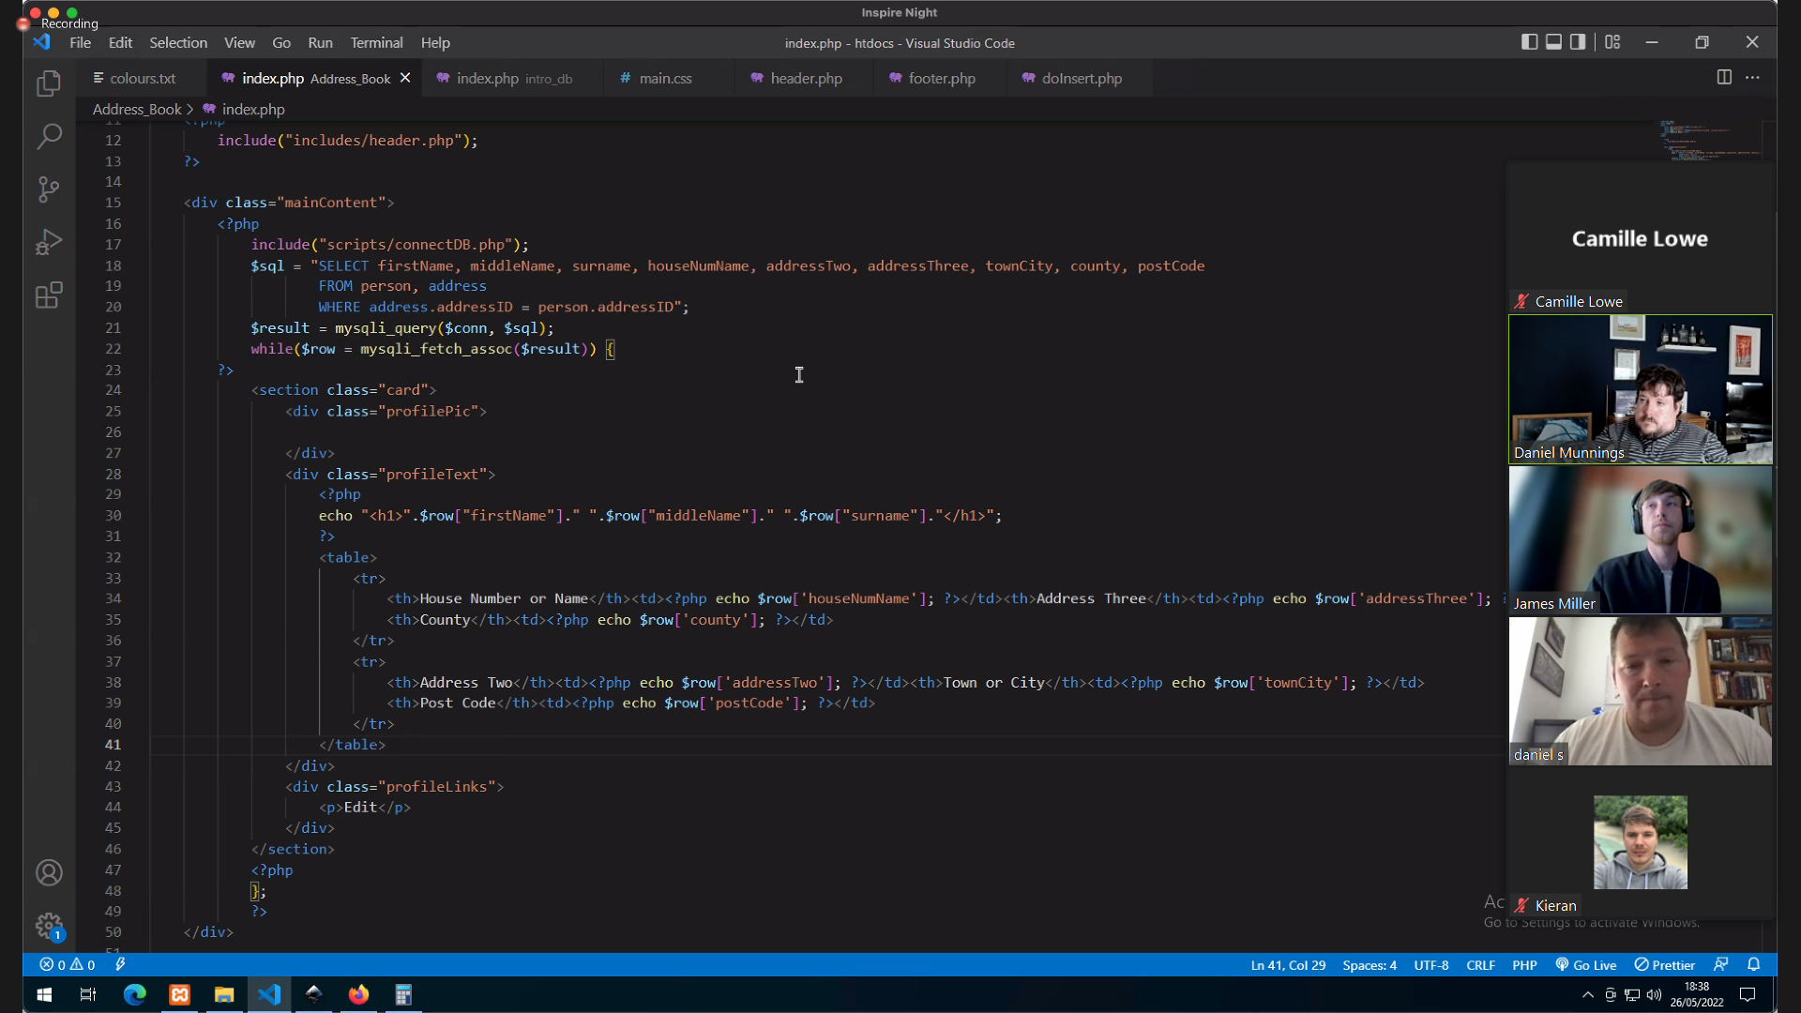

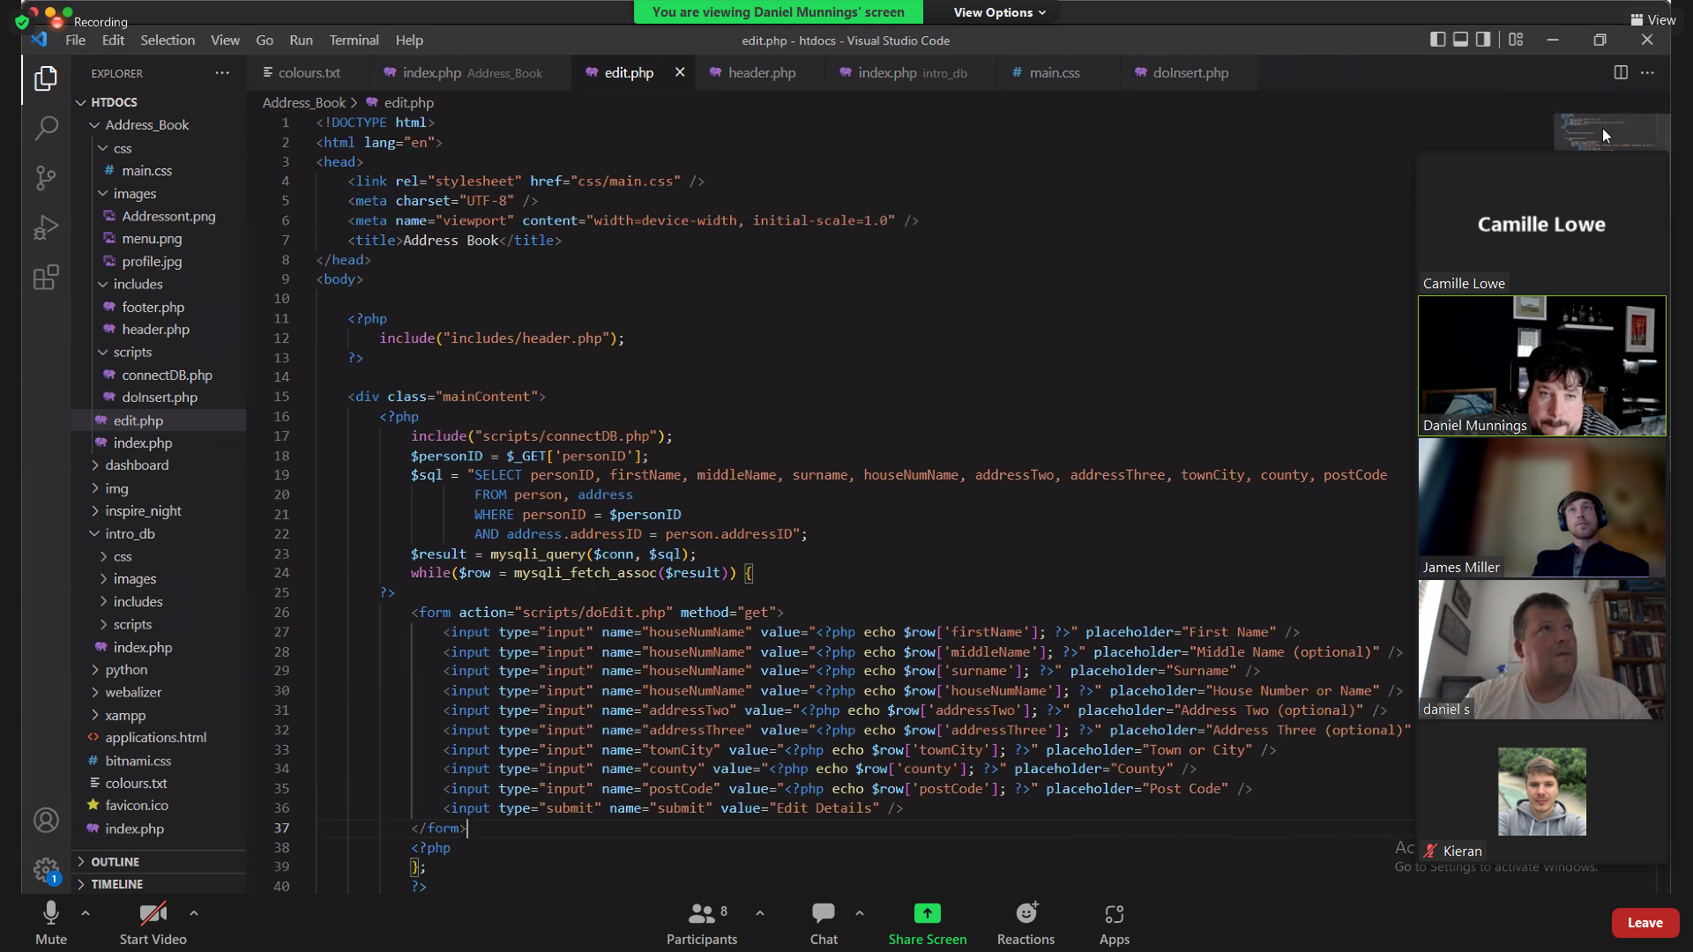

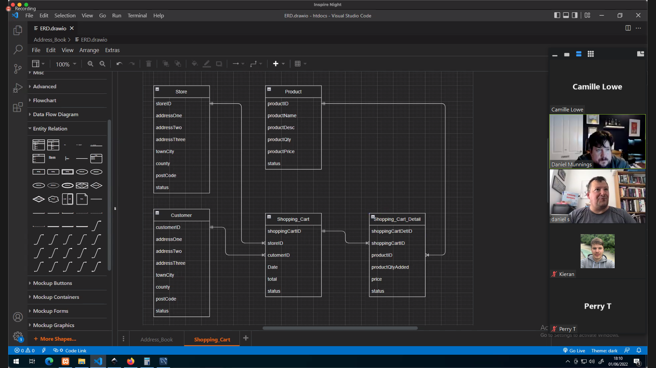

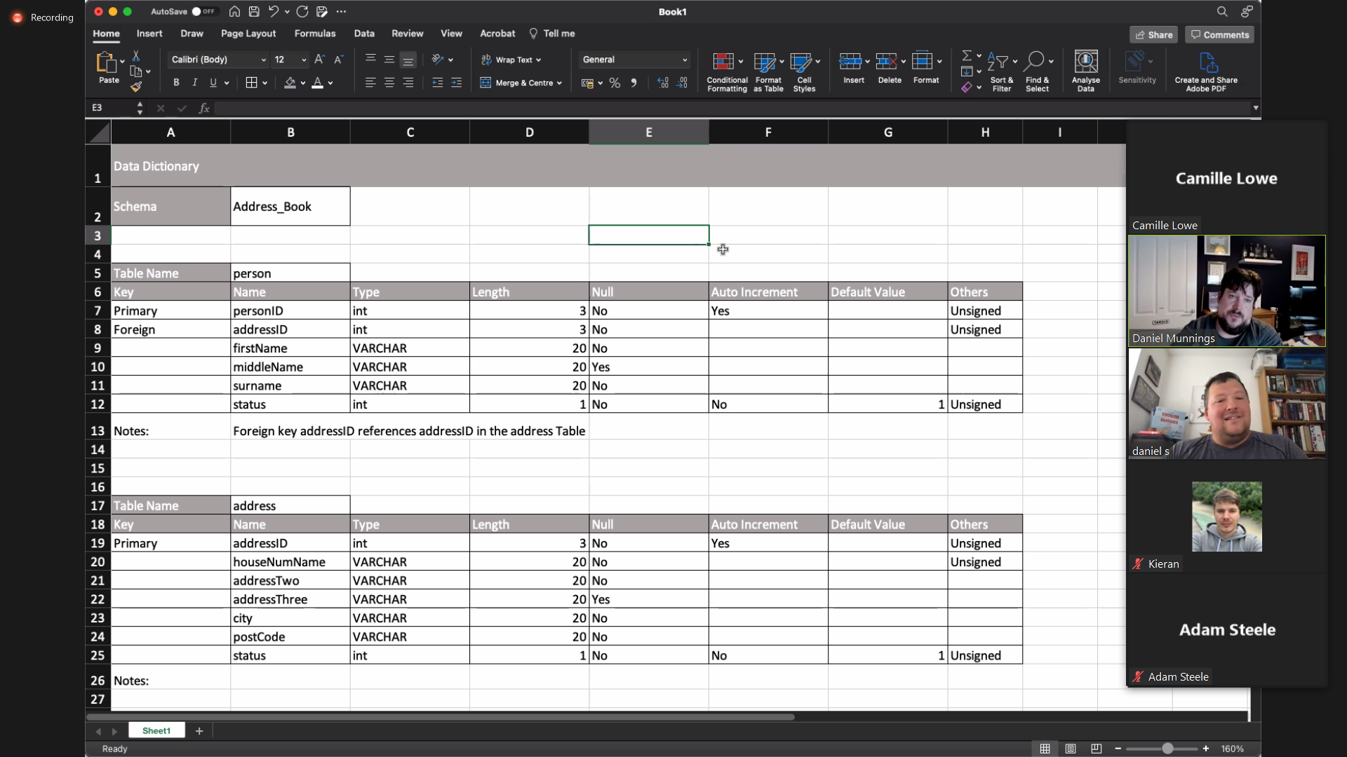

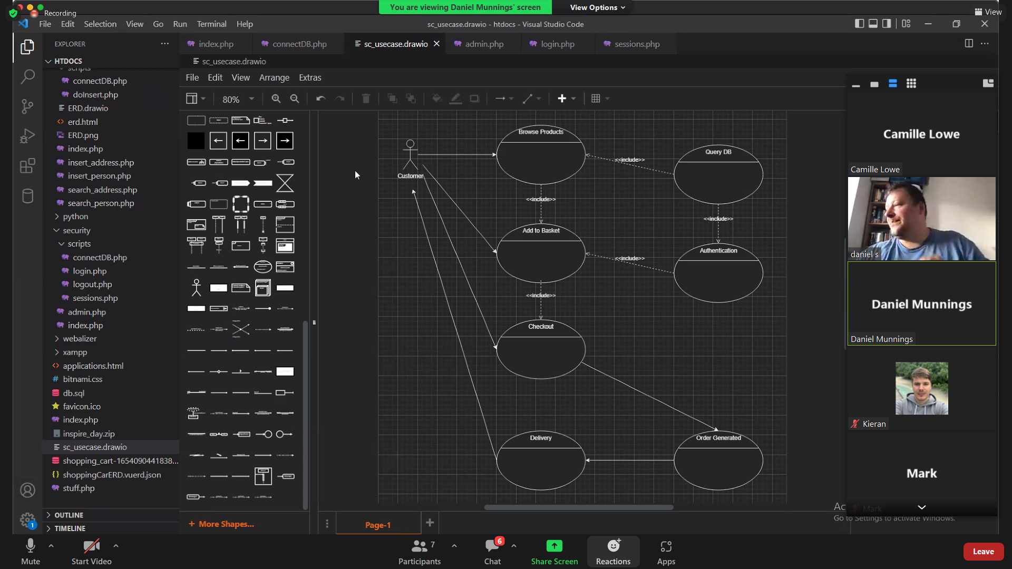

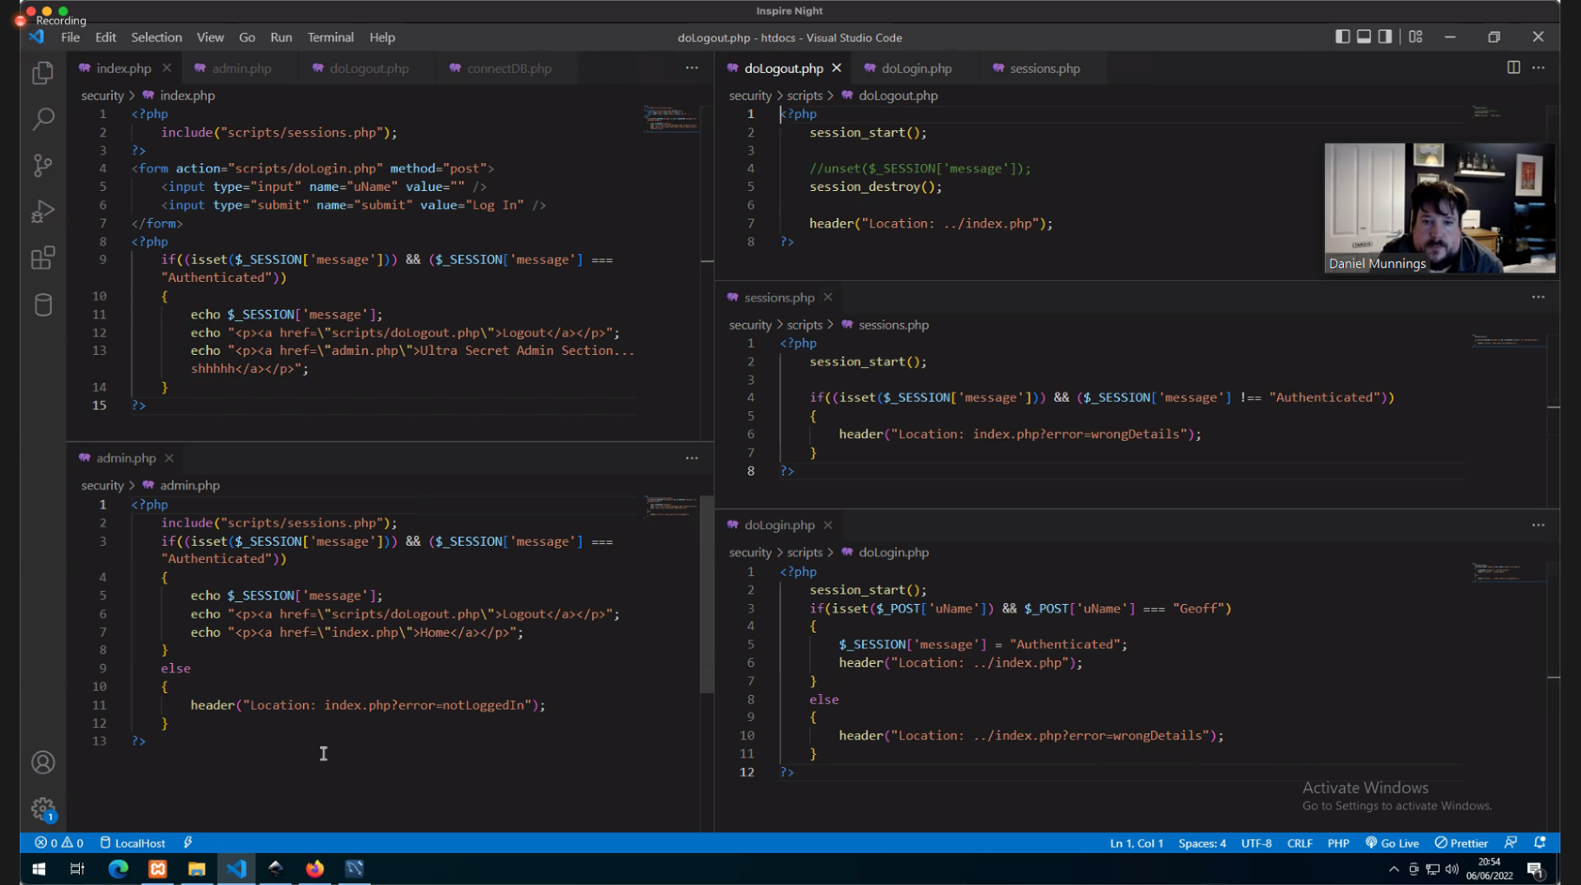

# References

TechTarget Contributor, 2021. *variable.* [Online]   
Available at: https://www.techtarget.com/whatis/definition/variable#:~:text=In%20programming%2C%20a%20variable%20is,uses%20when%20it%20is%20running.  
[Accessed 28 May 2022].